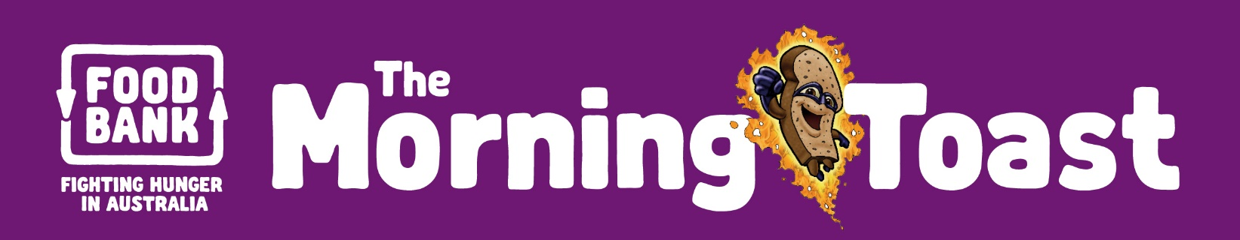

Term 1, 2016

linking foodbank schools across the state

The Morning Toast is a quarterly newsletter to update Foodbank’s Healthy Food for All® schools on the latest School Breakfast Program, Food Sensations® and Regional Strategy news and information!

Superhero Foods HQ now Live!

The latest breakthrough in the Superhero Foods story is the new Headquarters website! This website provides a range of fun and exciting nutrition education resources for teachers and students which are linked to the national curriculum. Launched on 1 March 2016, Superhero Foods HQ has been developed in consultation with teachers and health professionals as a one-stop shop providing access to a host of free nutrition education resources.
Registered School Breakfast Program schools are welcome to download and/or order all resources free of charge! A sample pack of all the resources will arrive at registered SBP schools in the next few weeks (addressed to the Principal). In the meantime, check out the website http://www.supeherofoodshq.org.au.

As part of the launch, Foodbank WA partnered with Media Education in The West Australian to design and print an education poster and comic book version of the new Superhero Food storybook ‘Joe’s Epic Breakfast Adventure’. These resources have been delivered to thousands of students and teachers across WA.
This project was made possible with sponsorship from Harvey Fresh, a long-time supporter of the School Breakfast Program.

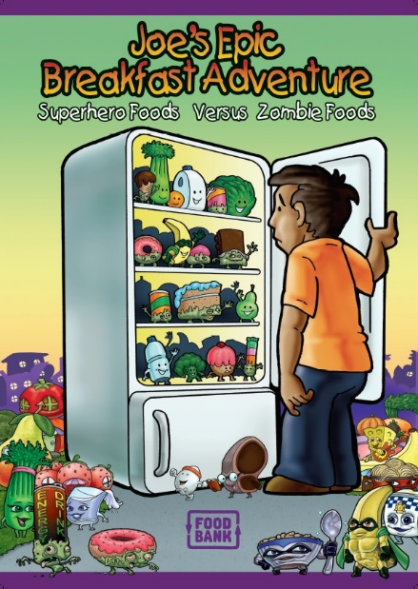

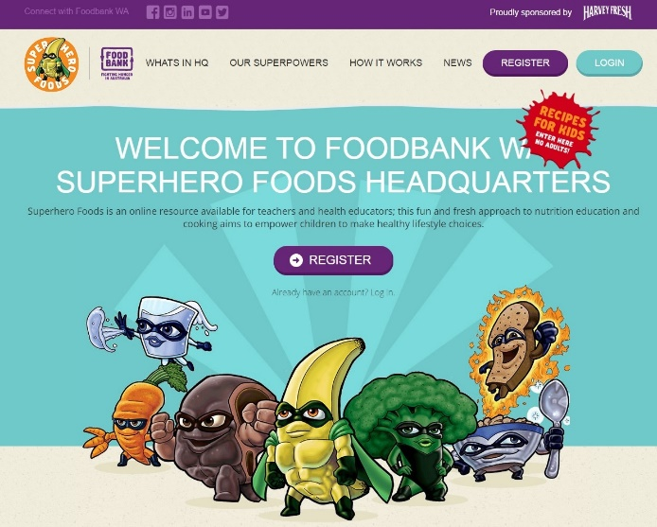
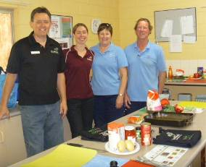
What Resources Are Available?
- Lesson plans from foundation level to year 10 – linked to the Health and Physical Education learning area of the Australian Curriculum. Each lesson plan clearly outlines the Achievement Standards for each year level.
- Recipe booklets containing quick, easy, tasty and healthy recipes!
- Breakfast placemats to be used for breakfast club or in the classroom
- Collector/game cards for fun & educational games
- A Storybook detailing Joe’s Epic Breakfast Adventure!
- A host of other useful resources including clip art and printable posters!

School Breakfast Program - 2015 Counter (January to December 2015)
Total Schools: 431 # Breakfasts/week: over 58,200
# Children involved: over 18,000 # Emergency meals/week: over 24,900

THE MORNING TOAST – Term 1, 2016

2016 School Breakfast Program Registration

Thank you to those schools that have submitted their 2016 School Breakfast Program registration. All schools will be sent a ‘2016 SBP Update’ pack in the coming weeks, containing the 2016 order form, certificate of involvement, posters and fact sheets.
The Healthy Food for All® team have put together a collection of healthy recipes to add more excitement to your SBP menu! All of the recipes are quick and easy to prepare and contain at least one core SBP product. The WA School Canteen Association (WASCA) has kindly categorised all of these recipes as either green or amber under the traffic light system, meaning you can be confident your students will be fuelling up on healthy breakfast foods. Please click here to download the new SBP Cookbook from the Healthy Food for All® website.
For more information about the School Breakfast Program, please contact Miranda Chester on (08) 9463 3213 or email miranda.chester@foodbankwa.org.au

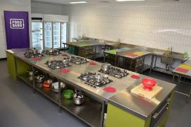
Food Sensations® at Foodbank!

Foodbank WA’s fantastic new BHP Training Kitchen is now available for Food Sensations® workshops with your school! Food Sensations® uses interactive activities and hands-on student cooking sessions to provide:
- A better understanding of basic nutrition
- Interactive lessons, tailored to your group
- A healthy cooking and food sharing experience!
Our 90 minute Food Sensations® sessions are run by qualified nutritionists, and are available FREE for any year group*, and can include a tour of Foodbank WA’s brand new facility! For more information, or to book your school group, please contact Jenny Tartaglia on 9463 3210 or email jenny.tartaglia@foodbankwa.org.au.
(*Foodbank WA site visits open to students in Year 3 or above)

Registrations open: 2016 School Food Appeal

It’s that time of year again when Foodbank calls on all schools to host a food drive to kick start our winter food collection. Sadly winter is one of the busiest times of year for Foodbank with food relief being in high demand. By running a food drive for Foodbank WA you will help make a BIG difference to the lives of many over the colder months. Last year, schools collected the equivalent of 7,084 meals – How many meals can you help us collect this year?
The 2016 School Food Appeal will take place from Monday 30 May to Friday 17 June 2016.
Every school goes in the running to win the almighty trophies for collecting the Highest Volume per Student and the Highest Volume Collected Overall (based on weight of product collected).
To register your school’s interest, please contact Karla Cavalli (Marketing & Fundraising Officer) on 9463 3232 or via email karla.cavalli@foodbankwa.org.au.
Together we can fight hunger in our community.

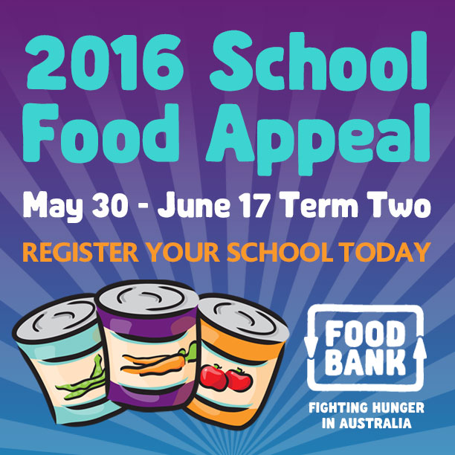

Healthy Food for All® Staff Changes

Healthy Food for All® Staff Changes

Food Sensations® in Schools – 2015 Counter (January to December 2015)
# Schools: 85 # Sessions: 202 # Students: 4,248

School Breakfast Program & the Healthy Food & Drink Policy

Foodbank Kalgoorlie Trading Hours
We are excited to announce that Foodbank Kalgoorlie opening days have extended from four to five days a week. Feel free to drop by between 9am and 2pm to stock up on SBP product.

New Manager for Foodbank Peel
The Foodbank WA team farewelled Caroline Cox at the end of 2015, after three years service as Foodbank Peel Regional Manager. Caroline’s contribution has been invaluable – we will miss her smiling face and wish her all the best for the future.

We are excited to introduce Megan Reynolds as the new Foodbank Peel Manager. As a Mandurah local, Megan has strong ties to the community and agencies in the Peel region. Please make sure to say hello and make her welcome when you next visit!
Regional Branch Updates
THE MORNING TOAST – Term 1, 2016

As part of a whole-school approach to healthy eating, Foodbank WA encourages schools to abide by the Healthy Food and Drink Policy when running their School Breakfast Program. Whilst all School Breakfast Program product supplied by Foodbank WA complies with this policy, it is important to consider any food or drink products sourced from elsewhere in terms of this Policy.

We encourage School Breakfast Program coordinators to get to know the person running the canteen (if a canteen exists at your school). Canteen managers have a good working knowledge of the Healthy Food and Drink Policy traffic light system and the types of food and drinks that can be served. Foodbank WA also has some great resources, including recipes, to help guide schools in choosing healthy food and drink options for breakfast.

It is important to remember that children don’t need a different breakfast item everyday - they simply need something healthy and wholesome to get them through the long school day.

To find out more about the Healthy Food and Drink policy and the traffic light system, visit the Western Australian School Canteen Association website: www.waschoolcanteens.org.au/

Food Sensations for Adults
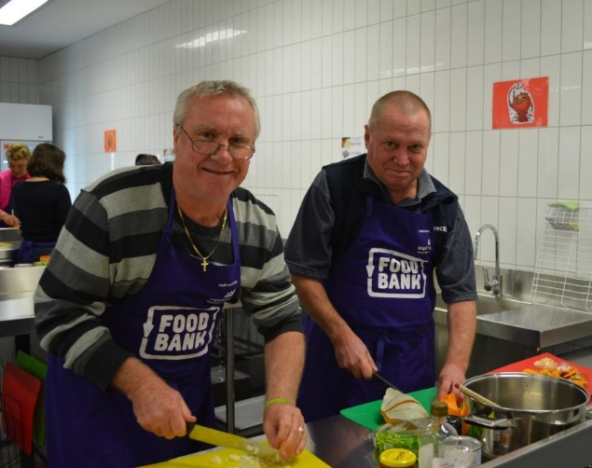

Food Sensations for Adults is a nutrition and cooking program designed to give adult participants a good understanding of healthy eating as well as skills in how to purchase and prepare healthy foods. The program is designed to provide a hands-on learning experience.
Foodbank is available to come out to your school or community group to host a program of 4 sessions for parents or participants can come out to Foodbank WA’s new BHP training kitchen facilities. The session content consists of healthy eating, meal planning and budgeting, label reading and food selection as well as food preparation and cooking. Upcoming session times:

Regional Strategy – 2015 Counter (January to December 2015)
Regions Visited: Midwest, Wheatbelt, Pilbara, Kimberley, Goldfields-Esperance, Great Southern, Southwest, Peel FS® School Sessions: 115 (1,937 students involved)
Towns/Communities Visited: 23 FS® Educator Training Days: 11 (60 trained)
Number of Schools Visited: 33 Distance travelled: 33,251 km

Location: Foodbank WA 23 Abbott Rd, Perth Airport
 | Topic | Dates | Time
Session 1 | Healthy eating and cooking | 5th April | 10.30am-12.30pm
Session 2 | Label reading, food selection and cooking | 12th April | 10.30am-12.30pm
Session 3 | Meal planning, budgeting and cooking | 19th April | 10.30am-12.30pm
Session 4 | Gardening for health and cooking | 26th April | 10.30am-12.30pm

If you are interested in coming out to Foodbank or hosting a Food Sensations for Adults session please contact Vanessa Bobongie on 9463 3214 or via email vanessa.bobongie@foodbankwa.org.au.

Healthy Food for All® Supporter Hall of Fame!
THE MORNING TOAST – Term 1, 2016

BHP Billiton
Since 2011 BHP Billiton have partnered with Foodbank WA to take the School Breakfast Program and Food Sensations into the Pilbara. Through this partnership Foodbank WA were able to provide breakfast to over 2000 students and teach essential cooking and nutrition skills to nearly 3000 students, 150 community members and 86 educators in addition to other initiatives that were introduced to the region. BHP Billiton have been a generous supporter of Foodbank WA and we look forward to strengthening the partnership over the coming years.

Newman’s Own Foundation
Newman’s Own Foundation generously donated US$10,000 (AUS$12,179) toward the purchase of School Breakfast Program food product. Whilst the number of schools registered for the program remained stable, the quantity of food product supplied to schools increased by over 10% compared to 2014. This growth in product supply is attributed to an overall demand for more food from existing schools, along with a rise in the number of breakfasts (4.9% increase) and emergency meals (9.3% increase) served. Increasing product costs are also a major factor. Without the generous support of Newman’s Own Foundation, Foodbank WA would not have been able to meet this increased demand for service during 2015.

PERTH CENTRE FOR HUNGER RELIEF |  |  |  |  |  |  |  |  | ALBANY
School Breakfast Program Coordinator: Miranda Chester |  |  |  |  |  |  |  |  | Manager: Rod Pfeiffer
☺ | 23 Abbott Road, Perth Airport WA 6105 |  |  |  |  | Mon to Wed: 9am – 3pm  Thursday: 7.30am – 3pm  Friday: 9am – 3pm |  |  | ☺ |  | Unit 2a 5-7 Cockburn Rd  Mira Mar Albany WA 6330
 | PO Box 143 Cloverdale WA 6985 |  |  |  |  |  |  |  |  |  | 9842 6645
 | 9463 3213 (SBP Direct) |  |  |  |  | www.healthyfoodforall.com.au  info@healthyfoodforall.com.au |  |  |  |  | 9842 6645
 | 9258 5177 |  |  |  |  |  |  |  |  |  | Mon to Fri 9am – 3pm
GERALDTON |  |  | BUNBURY |  |  |  | KALGOORLIE-BOULDER |  | PEEL
Manager: Pat Hodges |  |  | Manager: Carol Hearn |  |  |  | Manager:  Sandy Lee King |  | Manager: Megan Reynolds
☺ |  | 11 Box Street  Geraldton WA 6530 | ☺ | 5 Clifford St  Bunbury WA 6230 |  |  | ☺ | 175 Forrest Street  Boulder WA 6430 | ☺ | Unit 1, 68 Reserve Drive  Mandurah WA 6210
 |  | 9964 8011 |  | 9726 2362 |  |  |  | 9093 0284 |  | 9581 9200
 |  | 9964 8022 |  | 9726 2363 |  |  |  | 9093 0284 |  | 9581 9211
 |  | Mon- Thurs 7.30am – 2.30pm  Friday 7.30am – 1pm |  | Mon to Fri 9am – 3pm |  |  |  | Tues to Fri  9.30am – 2.30pm |  | Mon to Fri 9am – 3pm
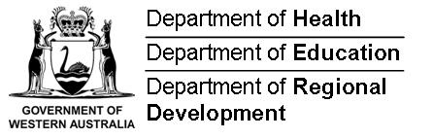
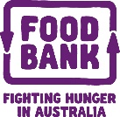
Channel 7 Telethon Trust
Telethon continues to support the purchase of healthy breakfast product, for distribution to School Breakfast Program schools across the state. Without the support of Telethon over the past 9 years, the Program would not have grown to support over 18,000 students every week across WA.
On behalf of all School Breakfast Program schools across Western Australia, we thank the Channel 7 Telethon Trust for their generous and ongoing support. We look forward to maintaining this very positive and valuable partnership for many years to come.

Proudly Supported by:
Foodbank WA’ Healthy Food for All® team would like to acknowledge the following Supporters:
Questions? Contact Foodbank!

